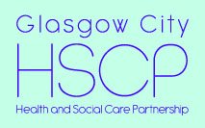

Glasgow City Health and Social Care Partnership

Summary of North East Locality Plan 2019 - 22

DRAFT

INTRODUCTION

Glasgow City Health and Social Care Partnership (GCHSCP) is required by the Public Bodies (Joint Working) (Scotland) Act 2014 to produce a Strategic Plan https://glasgowcity.hscp.scot/publication/gchscp-strategic-plan-2019-2022 for the health and social care services and functions delegated to the Integration Joint Board by Glasgow City Council and NHS Greater Glasgow and Clyde. These services are jointly delivered as the ‘Glasgow City Health and Social Care Partnership’ under the guidance of an Integration Joint Board.

The GCHSCP Strategic Plan covers health and social care services across the entire City. Each of the three local areas (North East, North West and South) that make up GCHSCP develop their own Locality Plan with partners including patients, service users, carers and the third and independent sectors. Locality Plans show how the Strategic Plan is being implemented locally and are updated each year to reflect feedback from stakeholders; ensuring services reflect local priorities, needs and community issues.

This document provides a summary of the North East Locality Plan 2019 - 2022. The full version can be viewed here: https://glasgowcity.hscp.scot/sites/default/files/publications/ITEM%20No%2012%20-%20Draft%20HSCP%20Locality%20Plans%202019-22.pdf.

This summary provides information on key areas of performance across our care groups and sets out the strategic priorities and actions that are being implemented on a city wide basis and in North East Locality.

About North East Locality
Glasgow City is the largest HSCP in Scotland by population and budget and is responsible for health and social care provision across three localities in the City; North West, North East and South Glasgow. North East Locality covers a population of 170,613 people.

As well as having responsibility for supporting the delivery of the range of services set out within this plan to our local population, the Assistant Chief Officer for the North East Locality also has a lead responsibility within Glasgow City HSCP for managing all Children and Family services

GCHSCP STRATEGIC PLAN 2019-2022

Strategic Priorities and Actions
The detailed priorities and actions set out in the GCHSCP Strategic Plan are grouped under five strategic priorities, namely:

- early intervention, prevention and harm reduction
- providing greater self-determination and choice
- shifting the balance of care
- enabling independent living for longer
- public protection

Locality Plan 2019-2022 Priorities and Actions
Priority activities and actions will be delivered consistently across each locality area and are identified as “city-wide”; however they will be delivered and monitored by each locality. Some specific actions will be delivered in a single locality, reflecting local needs and priorities.

A comprehensive list of city-wide and local strategic priorities and actions can be found in the full Plan here: https://glasgowcity.hscp.scot/sites/default/files/publications/GCHSCP_Strategic_Plan_2019_1.pdf

Specific priorities for North East Locality for 2019 – 2022 include:

- Ensure effective consultation with young people and wider groups in the continued development of the NE Health and Social Care Partnership
- Deliver new, purpose built accommodation for mental health acute inpatient accommodation at Stobhill Hospital
- The North East Women’s Team (NEWT) will contribute to a citywide evaluation of services for Women within the Criminal Justice system
- Continue to Develop the Intensive Outreach Family Support Service (IOFSS) .The aim of the service is to provide intensive community supports to prevent young people being taken in local authority care

Health and Wellbeing
The Strategic Plan sets out the priorities for the HSCP in terms of prevention and early intervention. Whilst keeping people healthier for longer is one of the HSCP’s priorities, improving the health and wellbeing of the population requires consideration of the key causes of health inequalities. The HSCP recognises that within the City there are people severely affected by poverty and deprivation, and this is one of the causes of health inequalities that health and social care services must seek to alleviate. Glasgow
City HSCP understands that tackling health inequalities and achieving health equity requires the removal of barriers to accessing and delivering services that are sensitive to the social circumstances experiences by citizens. The HSCP is committed to working with our community planning partners to implement the NHS Greater Glasgow and Clyde Public Health Strategy, Turning the Tide through Prevention, which describes six priority actions for improving the public health of people across the Greater Glasgow and Clyde area. A copy of the Strategy can be found here: https://www.stor.scot.nhs.uk/handle/11289/579831.
The adult Health and Well Being Survey has been undertaken by the Health Board in NHSGGC on a three yearly basis since 1999. Below is some key data and trend information for North East Locality including the demographic profile from the 2018 Report

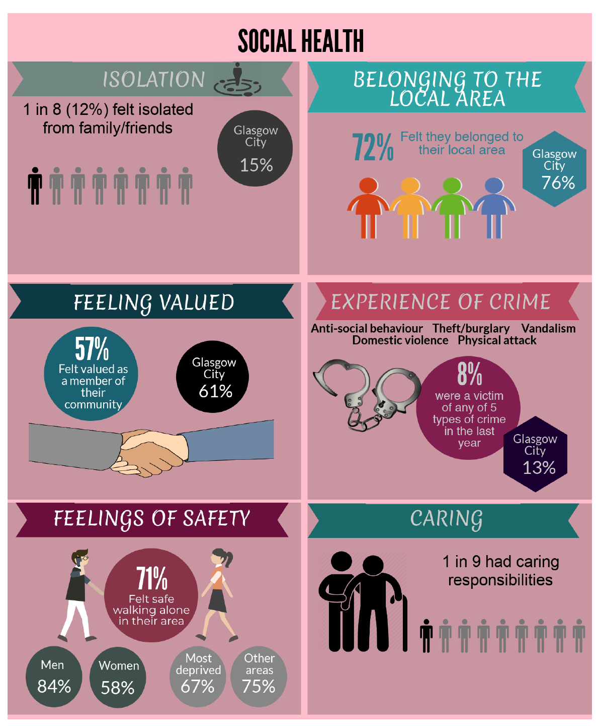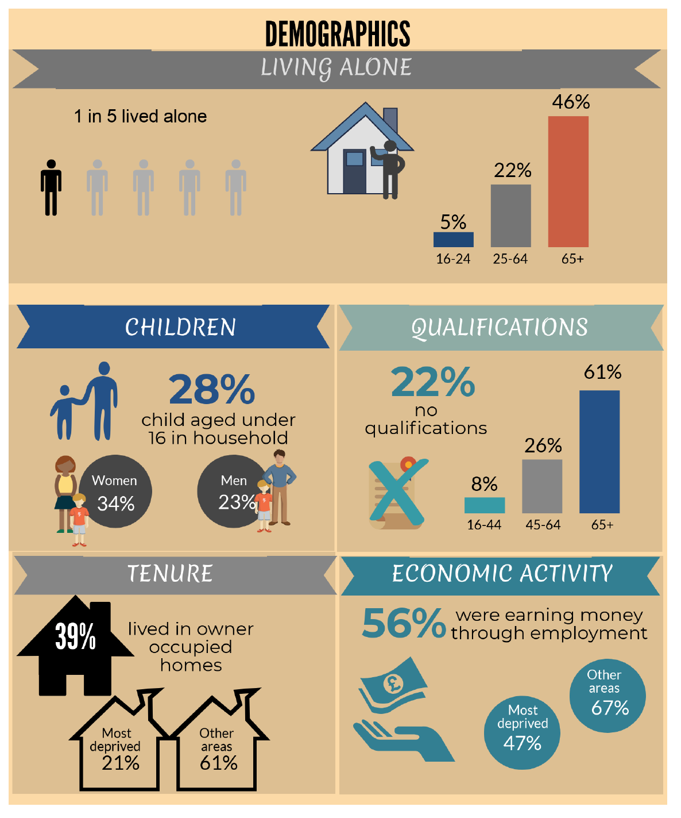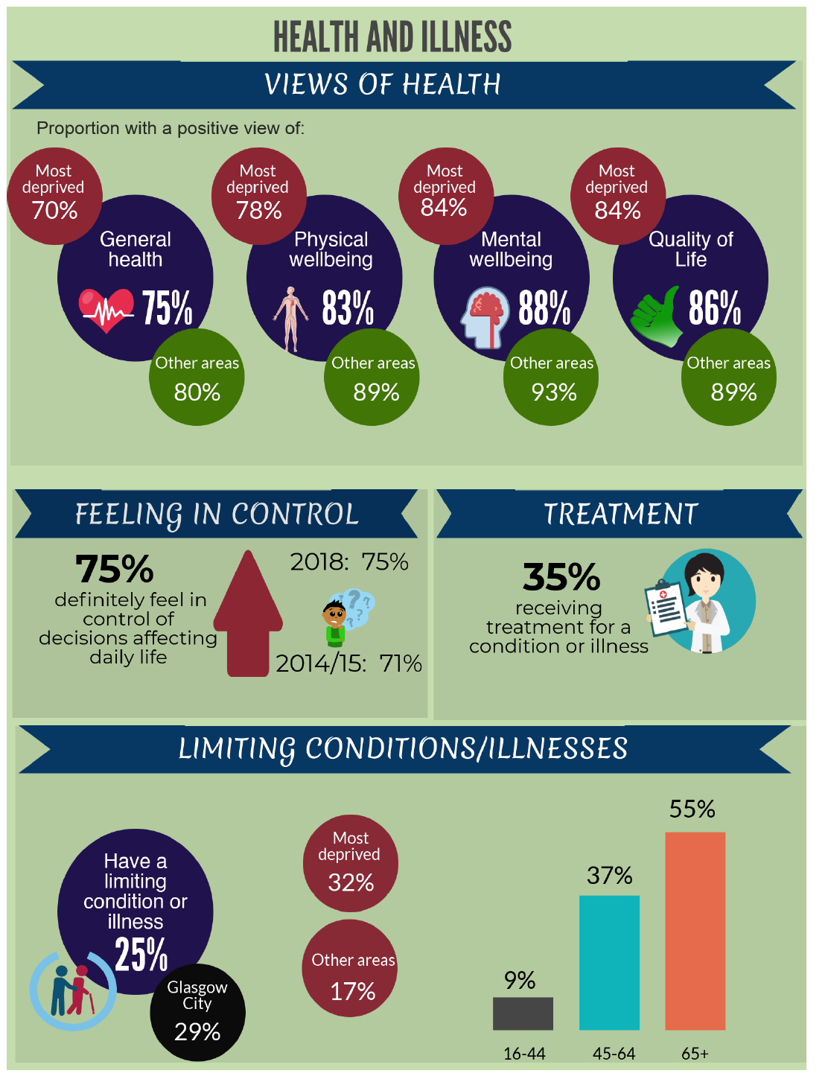

Performance
GCHSCP produces an annual performance report which reflects on performance in relation to national and local indicators and commitments set out in the Strategic Plan. Performance is also measured at a care group and service level via a variety of internal and external governance arrangements.
Specific achievements in North East Locality in 2018 -19 include:
- Successfully Developing Plans for the new North East Social Care Hub
- Through Lottery funding successfully Developed the North East Test of Change Consortium approach with the Third Sector
- Continue to deliver specialist Hepatitis clinics alongside opiate replacement therapy. Specialist clinics have been established and there has been an increase in patients engaging in Hepatitis treatment
- Delivery of financial inclusion embedded into GP practices in Bridgeton and Parkhead
- A dedicated Intermediate Care Team to support older people to remain at home is now in place

A comprehensive list of city-wide and local performance information can be found here in the Annual Performance Report 2018-2019 here: https://glasgowcity.hscp.scot/sites/default/files/publications/HSCP%20Annual%20Performance%20Report%202018%2019_0.pdf

Transformation Programmes
Delivery of effective and lasting transformation of health and social care services is central to the vision of Glasgow City HSCP. Transformation is not just changing how services are structured. Transformation is about making significant changes to how services are planned and delivered in partnership with people who use them. A number of important
strategies and programmes are already under way that will transform how health and social care services in the City are delivered and experienced by patients, service users and carers. Whilst the Transformation Programmes are already delivering real and sustainable change for people in the City, further work is required.

Older People Services Transformation Programme
The strategy for older people and people with a physical disability signals a clear intention to shift the focus to enabling and supporting those who require assistance to enjoy the best quality of life possible, informed by choices they make for themselves. For older people’s health and social care this means a different attitude towards risk and its management across the entire system, particularly where older people themselves make a conscious choice to live with risk in the community. This approach will also apply to people with a physical disability. More information on the Older People Services Transformation Programme is available here: https://glasgowcity.hscp.scot/sites/default/files/publications/ITEM%20No%2007%20-%20Older%20Peoples%20Transformational%20Change%20Programme%202018-21_0.pdf

Adult Services Transformation Programme
In recent years in Adult Services there has been significant progress in shifting the balance of care and delivering more effective, community based services. Our strategy signals a clear intention to shift the focus towards more of a risk-enabling approach that maximises the opportunity for independent living, with a stronger emphasis on prevention, early intervention and supporting self-management of certain conditions. More information on the Adult Services Transformation Programme is available here: https://glasgowcity.hscp.scot/sites/default/files/publications/ITEM%20No%2006%20-%20Adult%20Services%20Transformational%20Change%20Programme%202018-2021_0.pdf

Children’s Services Transformation Programme
For Children’s Services our strategy aims not only to secure better outcomes and more positive destinations for children and young people but to enable Children’s Services to operate more efficiently and effectively across the City. The transformation programme for Children’s Services is designed to strengthen the local infrastructure to deliver a preventative strategy in the City. There is also a commitment and a determination to spend more of the IJB’s / GCHSCP’s resources in the City to ensure that where possible children and young people are helped to stay at home, in their neighbourhoods and in their local schools. To this end, the strategy is to seek to implement the aspirations of the Christie Commission, to avoid spending money in ‘failure demand’ and significantly shift money and interventions into the community. The Children’s Services Transformation Programme is available here: https://glasgowcity.hscp.scot/sites/default/files/publications/ITEM%20No%2006%20-%20Transformational%20Change%20Programme%20-%20Childrens%20Services%202018-21.pdf

Primary Care Improvement Plan
Glasgow City HSCP agreed a Primary Care Improvement Plan (PCIP) in Autumn 2018. The PCIP presents a major opportunity to transform primary care by supporting GPs to operate effectively as expert medical generalists. This involves GP’s leading multi-disciplinary teams, giving them more time to spend seeing patients and addressing the needs of the rising numbers of people with multiple and complex conditions. Our strategy includes enabling more support to be delivered in home and community settings and promoting greater self-management and choice to allow people to stay cared for appropriately and safely in the community for longer. More information on the PCIP can be found here:
https://glasgowcity.hscp.scot/sites/default/files/publications/ITEM%20No%2009%20%20Primary%20Care%20Improvement%20Plan_0.pdf

SUPPORT FOR CARERS
The Carers (Scotland) Act 2016 came into force on 1st April 2018 and places additional duties on Integration Joint Boards. The Act can be found here: http://www.legislation.gov.uk/asp/2016/9/contents.

Carers and young carers have been fully engaged and involved in the development of the Glasgow Adult and Young Carer Strategies. There are well established locality carer forums and a city-wide Carer Reference Group who are represented on the Carer Strategic Planning Group and the city wide operational delivery group. Young carer engagement has been facilitated through the Young Carer Strategy Group. The appointment of a Carers Champion and plans for quarterly engagement events with wider groups of carers will provide a focus for carers to influence the implementation of the Act. More information on the implementation of the Carers (Scotland) Act 2016 can be found here: https://glasgowcity.hscp.scot/sites/default/files/publications/ITEM%20No%2012%20-%20Implementing%20the%20Carers%20Scotland%20Act%202016_0.pdf

COMMUNITY ENGAGEMENT – LOCALITY ENGAGEMENT FORUM
North East Locality Engagement Forum (LEF) reviewed its membership in 2018 and agreed to work towards building a wider engagement network developing closer links with Housing providers, Carers, Mental Health service users and Refugees/Asylum seekers. Working in partnership with the Mental Health Foundation the Forum members took part in the making of an information video explaining the importance of civic participation focusing on promoting engagement with public services among refugee/asylum seekers. The production crew filmed discussions at one of the regular NE LEF meetings they also interviewed the chair who spoke about the contribution members can make to improving local services. The video will be released on the 25th September 2019 and shared throughout the refugee/asylum network.

A key aspect of this project is to make sure this seldom heard group form part of the mainstream engagement process rather than an exclusive one issue focus group. In addition to the work with the refugee/asylum seekers the forum has been collaborating with the Glasgow School of Art who are conducting research into developing a new type of community engagement platforms to raise participation levels among the general public.

Local people, community groups and organisations had an opportunity to discuss and give their opinions on a range of Locality topics including:

- North East Locality Plan 2018 – 19
- Development of the Volunteer Charter
- Older Peoples’ Services
- 70th Anniversary NHS Road Show
- Medical Surgery Closure Springburn Health Centre
- Implementation of the Mental Health Strategy
- Monitoring progress of the North East Health and Care Centre Hub
- Presentations from 3rd Sector partners such as Mental Health Network, Marie Curie

NE LEF members have met with Mental Health service recovery groups to discuss their ideas on service provision at the proposed North East Health and Social Care Hub. Examples from service users that are now actively being considered are a café to help combat social isolation with community garden maintained by volunteers to develop skills and build the confidence of local people who are in recovery. Further information about locality engagement in North East Glasgow can be found here: https://glasgowcity.hscp.scot/north east-locality-engagement-forum.

EQUALITES

As a public body, the IJB is required under the Equality Act 2010 to publish its own set of equality outcomes. It is also required to
report on progress in taking forward the equalities agenda and is expected to review policies and practices to ensure these eliminate discrimination, harassment and victimisation, and advance equality of opportunity and access for people with ‘protected characteristics’. Further information can be found in the Glasgow City HSCP Mainstreaming and Equalities Action Plan here:
https://glasgowcity.hscp.scot/sites/default/files/publications/IJB_Meeting_20160321_Item_10_Equalities_Mainstreaming.pdf

CONTACT INFORMATION

For more information about this summary or to request it in an alternative format, please contact:
Tony Devine, Community Engagement Officer on 0141 277 7554 or email tony.devine@ggc.scot.nhs.uk

